**Mobile App Development – Specification requirements**

When open the App then the first page should be a welcome page like the picture below:

Use our logo and find a good picture.

**1. Login page**

1.1 You can log in with Email, Phone or Facebook like the picture below. And with same info as below.

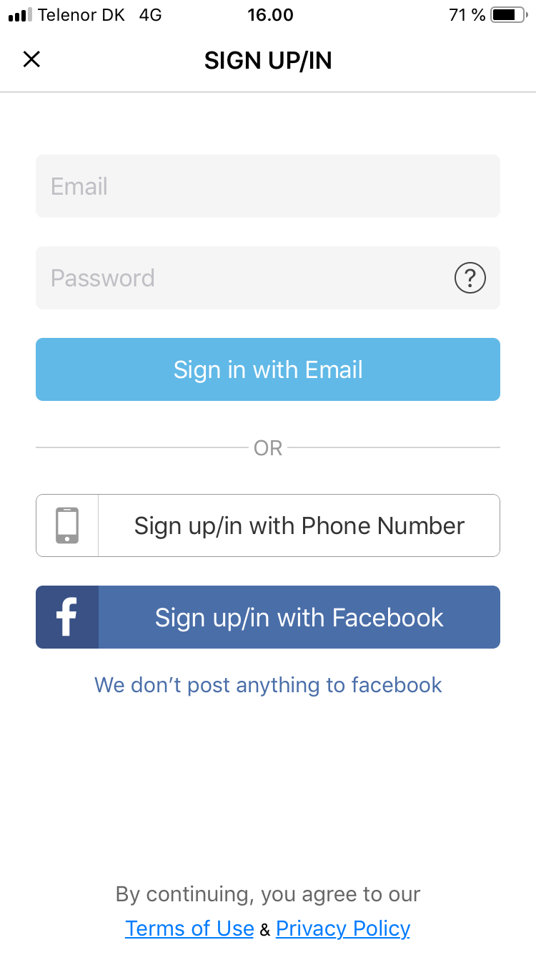

1.2 When clicking on log in with Phone then a page appear where you will need to enter you phone number based on the country location. Check the picture below. And use the same info.

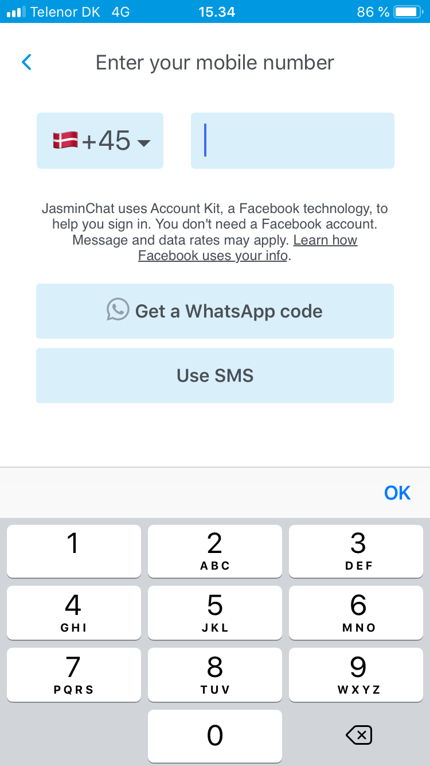

1.3 You will then receive a code to enter - either through What’s app or email. Instead of 6 digits then we will only have/use 4 digits.

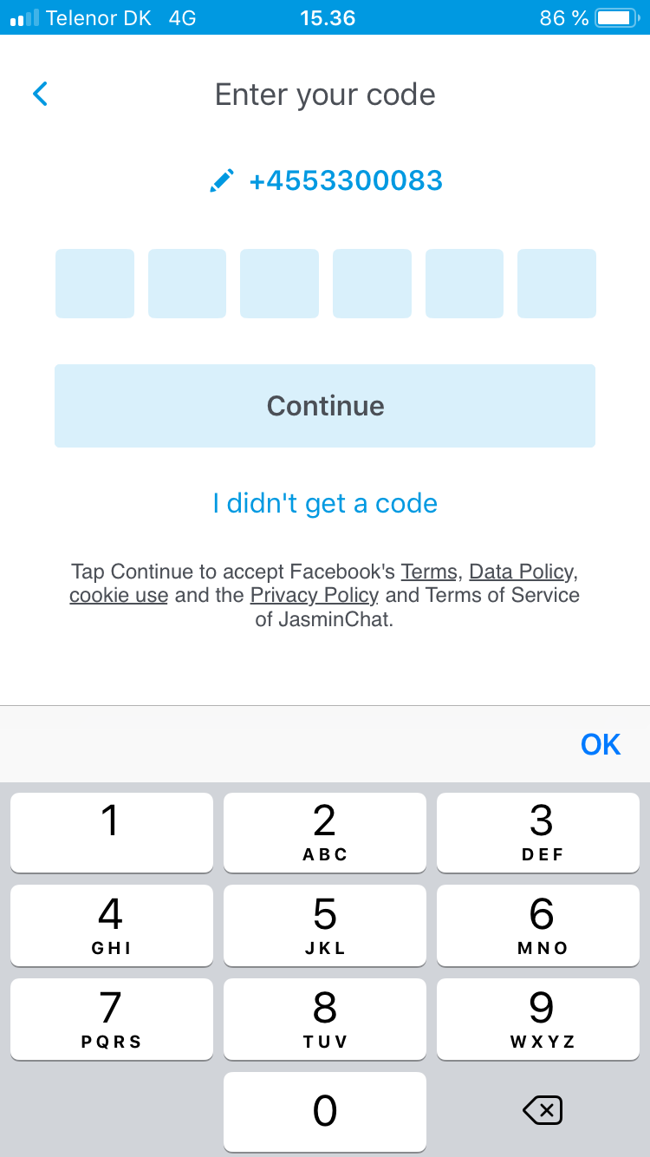

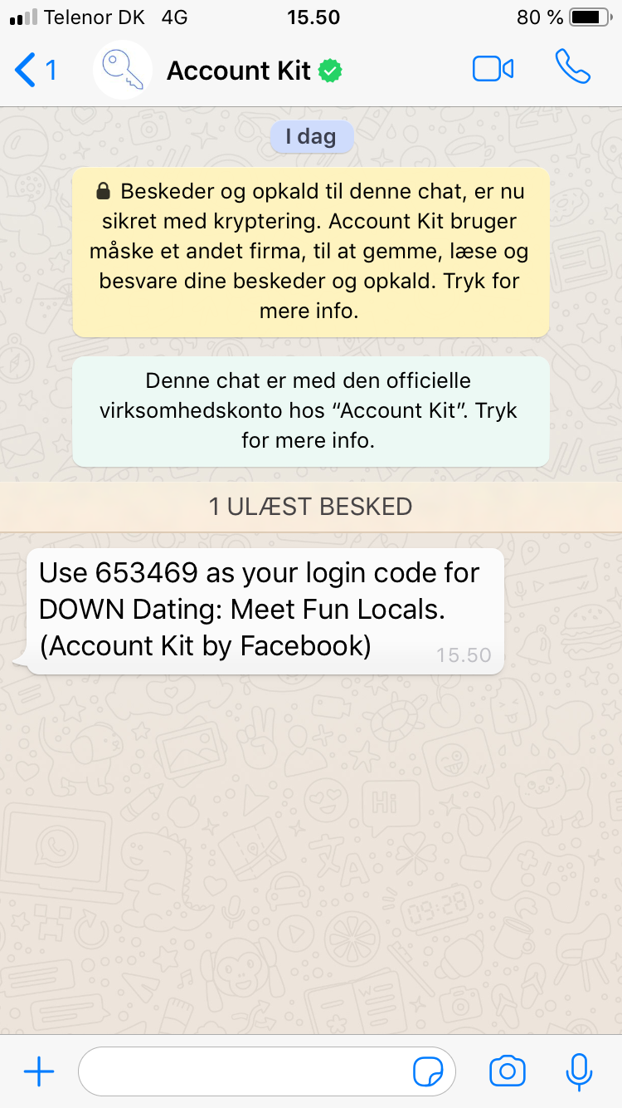

2. **Registration process**

Just after the user typed the 4 digits then redirect to the page where the user need to type Username, Gender choose (man or woman), Looking for (men, women or both), Birthday, Location (country and city). These info need to be typed before the user is able to create an account. After the user has typed these info then he can upload one (profile pic) or more pictures. You can get the inspiration from this picture below:

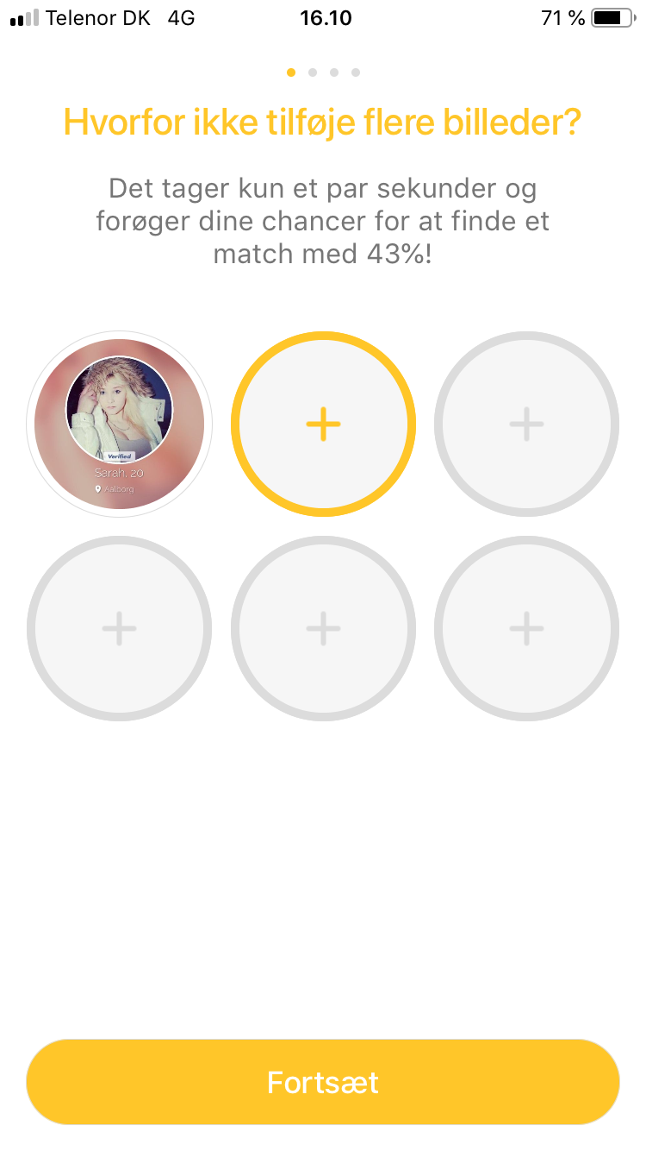

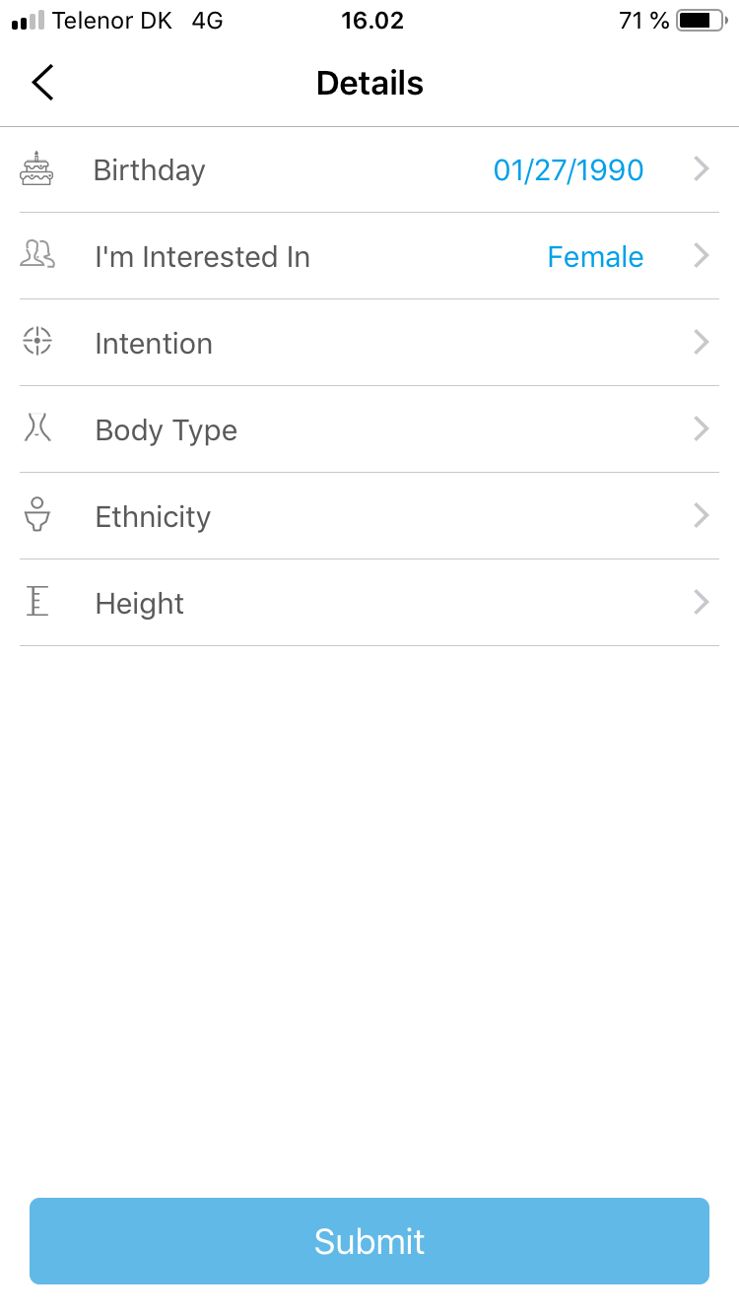

3. **Home page (like Jasminapp)**

3.1 First page will show Models who are ready for video chat and it is possible to click and see the profile details of each model. You will be able to click on All Models, My Favorites, Arabic Models, Hindi Models etc., and you will be able to scroll from right to left to see more categories as Russian, Danish etc.

Hot, Explore and Followed should not appear on our app. So instead of these then you can place categories there.

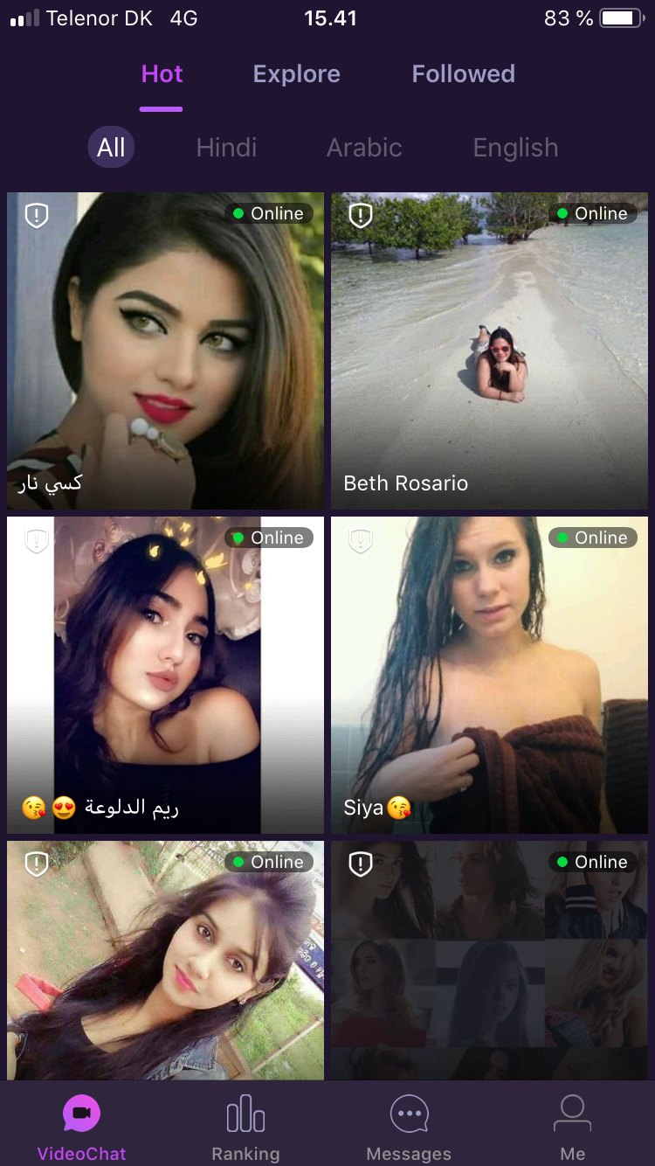

In the bottom we will have Models (VideoChat), Users (Videochat same design style as for Models), Messages and Me.

3.2 On profile detail page you will also be able to Chat, Add friend, favorite and Video call. On this page we need following info: Picture (you can scroll if more pictures), Username, Location, Age, ID number, About me and Gifts received. See picture below.

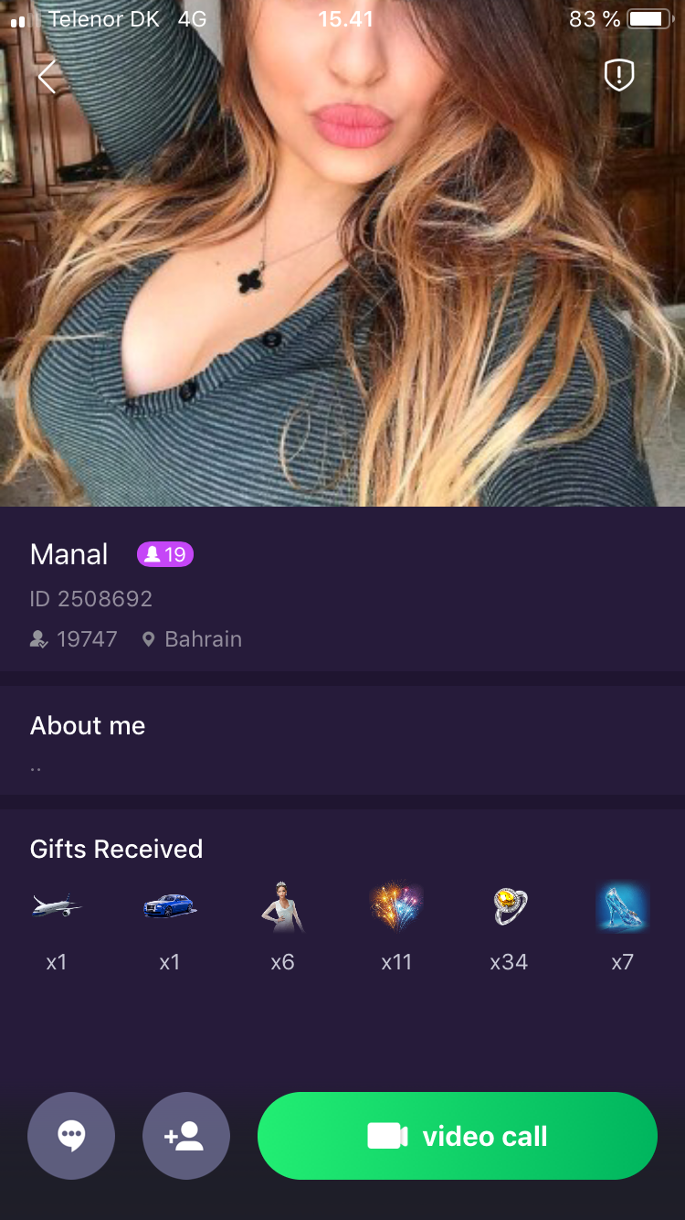

4. **Chat page.**

I think we don’t need to describe this field as it make sense what to do here.

5. **Me**

Here we will need the same content as the picture below. You will here be able to see how visited you and who favorite you. You will be able to see which premium package you and the amount of credit you have.

Settings you will be able to see your information and edit it.

